Beijing Language and Culture University
Application Guide for “Chinese +”Undergraduate Program
International Chinese Language Teachers Scholarship 2024

In order to cultivate qualified Chinese talents for international exchanges, the Center for Language Education and Cooperation (CLEC) of the Ministry of Education and Beijing Language and Culture University (BLCU) jointly established the "Beijing Language and Culture University International Chinese Language Teachers Scholarship ‘Chinese +’ Undergraduate Program".
- Application Eligibility
To be eligible, an applicant must:
- be a citizen of a country other than the PRC and in good health both mentally and physically
*If both or one parent of the applicant is a Chinese citizen and settled in a foreign country, and the applicant (without Chinese nationality) has a foreign nationality at birth, should have held a valid foreign passport or foreign nationality certificate for at least 4 years and have a record of actual residence in a foreign country for at least 2 years within the last 4 years (until April 30 of the enrollment year) (actual residence in a foreign country for 9 months in a year can be counted as one year, based on entry and exit stamps).
*Residents of China's mainland, Hong Kong region, Macau region and Taiwan region who have immigrated and acquired foreign nationality should also meet the requirements above when applying for undergraduate studies at BLCU as international students.
(For more details, please refer to http://www.moe.gov.cn/srcsite/A20/moe_850/202006/t20200609_464159.html released by the Ministry of Education of the People's Republic of China)
- be an academically excellent holder of high school diploma or its equivalent
- under the age of 25 until September 1, 2024. If under the age of 18, an applicant must obtain the approval of BLCU, and provide the guardian's notarial certificate and other relevant documents;
- have passed the HSK (Level 4) 210 overall; HSKK (Intermediate Level) 60;
- be friendly to China, have no criminal records, abide by the laws and regulations of the Chinese government and the rules and regulations of BLCU.

- Scholarship Coverage and Duration
- Scholarship program sponsors undergraduates
- Supporting Majors: International Organizations and Global Governance；Communication Studies
- Supporting Duration: 4-year major study
- Supporting Coverage: Accommodation fee, living allowance and comprehensive medical insurance
- Supporting Standard: dormitory on campus for free, living allowance of CNY 2,500 per month, comprehensive medical insurance of CNY 800 per year.

- Enrollment Time, Teaching Mode and Entry Requirements
- Enrollment time: August 28, 2024
- Teaching mode: international students only. International students attend classes with students from other countries. Some specialized courses may be taught in the same class with Chinese students.
- Entry requirements:
Major | Entry Requirements
International Organizations and Global Governance | 1. Chinese language requirements: HSK (level-4) 210 overall and above; HSKK (Intermediate Level) 60 or above  2. Pass the interview online
Communication Studies

- Application Procedures
  - Applicants log on to the International Chinese Language Teachers Scholarship application website (cis.chinese.cn), click “I want to apply” in the upper right corner, complete the registration, and log on to the program management platform.
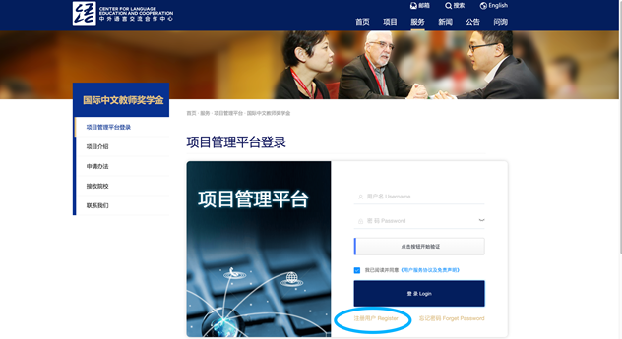

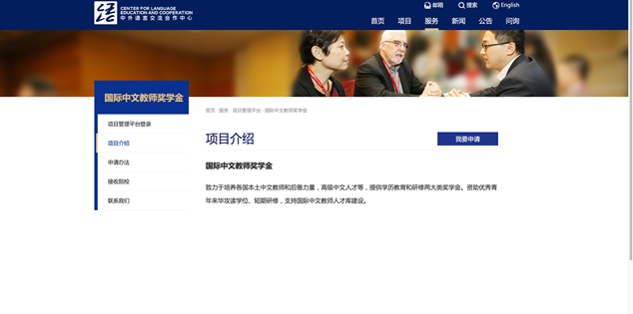
  - Click “Scholarship Application”, select “Joint Training Program” in the pop-up box, and then click the button to enter the “Application Form for International Chinese Language Teachers” page.
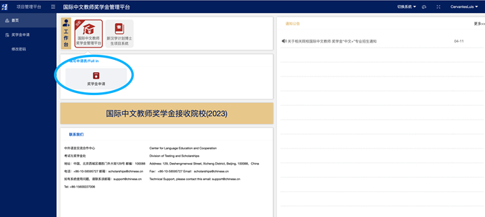

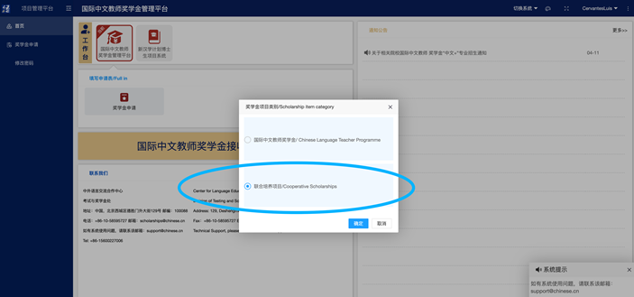

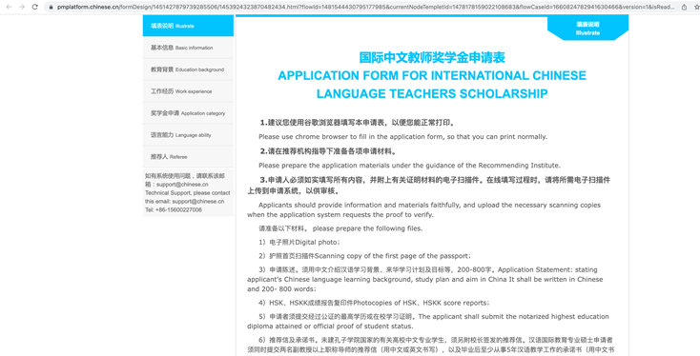
  - Fill in the application form as required, and select “Chinese + Vocational and Technical Training (Undergraduate)” in “Scholarship Category”; You can choose "Chinese + international organizations and global governance" or “Chinese + communication” as your major.
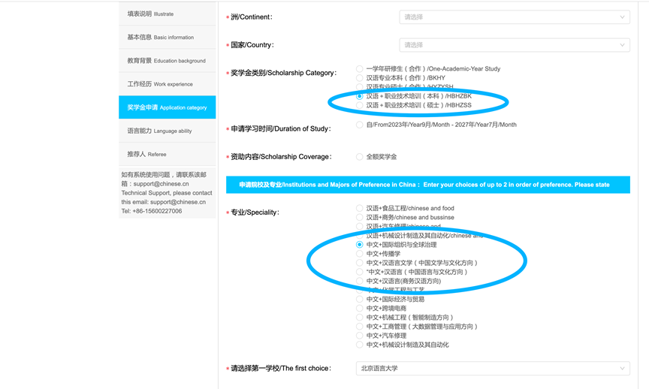
  - After confirmation, you can submit the application materials. Please pay attention to the application process, review opinions and scholarship evaluation results; The successful applicant must confirm with BLCU to go through the procedures of studying in China, print out the scholarship certificate online, and register at the BLCU on the designated date as per the admission letter.

Recommending Institutions: Confucius Institutes, independent Confucius Classrooms, selected HSK test centers, foreign educational institutions, Chinese language teacher training programs/Chinese departments at foreign universities, professional associations for Chinese language teaching, Chinese embassies (consulates) abroad may recommend outstanding students and in-service Chinese language teachers to further their studies in international Chinese language education and related programs at BLCU.

The Application Deadline (Beijing Time)
May 05, 2024

BLCU will organize further interviews for applicants who meet the requirements of the scholarship, and will comprehensively consider the factors such as the applicant's Chinese level, learning potential and interview results, and recommend them to the center for evaluation.
CLEC will entrust an expert panel to review the applications. Decisions will be based on HSK levels and scores, Chinese research ability, geographical distribution, and other factors. After the approval of the center, BLCU will inform the applicants in time and issue the admission notice to arrange the enrollment.

- Application Materials
  - a scanned copy of passport photo page
  - a certificate of the senior high school diploma (or proof of expected graduation) and complete transcript.
Students with proof of expected graduation must submit formal certificate of the senior high school diploma before the starting and registration time of BLCU. If not, their qualifications for the scholarship will be canceled.
  - certificates of a minimum score of 210 on the HSK Test (Level 4) and 60 on the HSKK test (Intermediate Level); valid within 2 years
  - recommendation letter (written in Chinese or English, no fixed format; the recommenders need to sign and provide effective contact information).
  - For applicants under the age of 18, their parents should entrust a non-Chinese citizen residing in China or a Chinese residing in Beijing with the student’s guardianship, and provide notarized guardianship guarantee statement.
Note:
- All the consequences caused by providing false documents shall be borne by applicants themselves.
- Additional documents will be required by BLCU on certain conditions.

- OTHERS
1. Degree students are subject to the annual assessment according to the Annual Assessment Procedures of the International Chinese Language Teachers Scholarship.
2. Students who fail to pass the pre-enrollment medical examination, withdraw from school before completing the program, fail to register at the university without prior permission, or suspend their studies will be disqualified for the scholarship.
3. Each applicant can only apply for one scholarship provided by Chinese government. Multiple applications for different scholarships will be considered invalid and such applicants will be disqualified from scholarship.

VII. CONTACTS
International Admissions Office
Beijing Language and Culture University
Tel: 86-10-82303951
Fax: 86-10-82303087
Email: cn@blcu.edu.cn（Chinese）
en@blcu.edu.cn（English）
Web: http://admission.blcu.edu.cn

Office of Confucius Institute
Beijing Language and Culture University
Tel: 86-10-82303272
Fax: 86-10-82303327
E-mail: blcu_cis1@163.com
Web: http://ci.blcu.edu.cn/

